LabSheet 6

Hibernate Registration Form Example with JSP, Servlet, MySQL using Annotation

Problem Statement : User registration processing using Hibernate Annotation
1. Creating a User Registration form using JSP
2. Submit the User Registration form with a POST request
3. After form submission the corresponding servlet will get called
4. UserController class handles all the request parameters and sends a request to the UserDao class to save this data to the database.

1. Create a Dynamic Web Project in Eclipse IDE
To create a new dynamic Web project in Eclipse:
1. On the main menu select File > New > Project...
2. In the upcoming wizard choose Web > Dynamic Web Project.
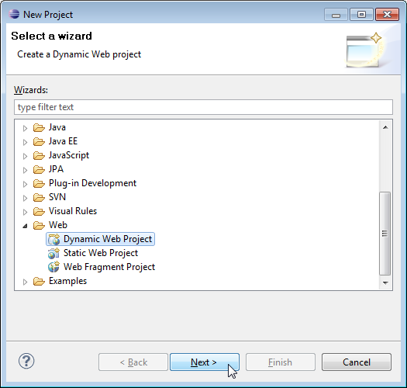
3. Click Next.
4. Enter project name as "hb1";
5. Make sure that the target runtime is set to Apache Tomcat with the currently supported version.

2. Add Jar Dependencies
You can get these jar dependencies from the GitHub repository (the link given at the end of this tutorial). Add the latest release of the below jar files to the lib folder:
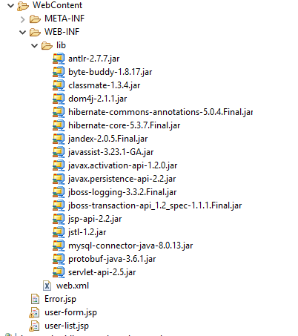

3. Project Structure
Create project structure or packaging structure as per the below screenshot:
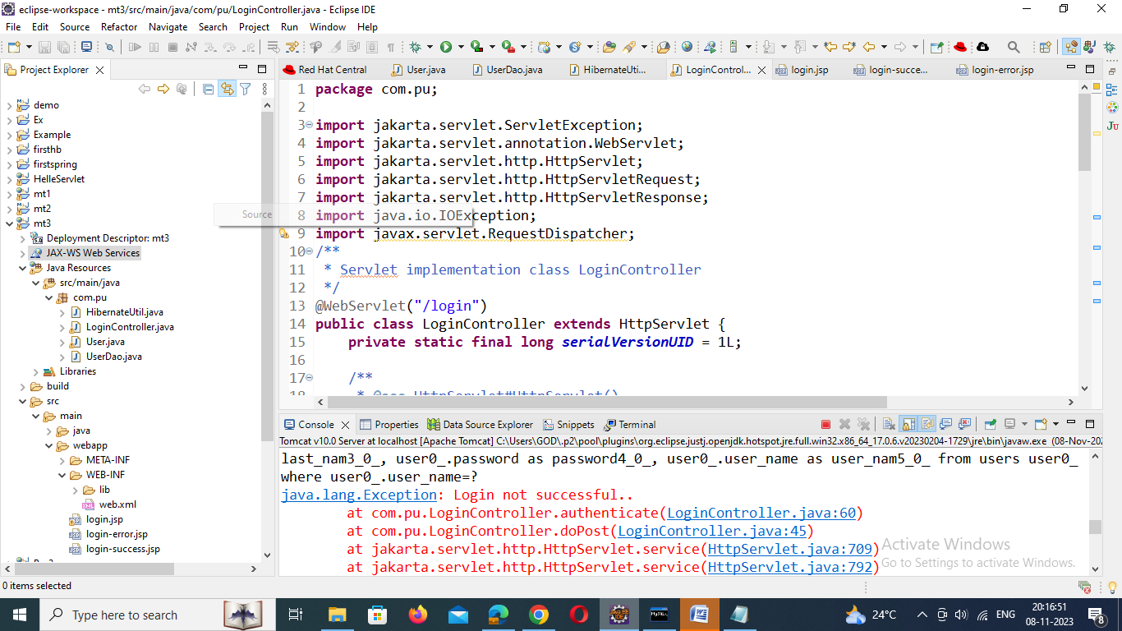

4. MySQL Database Setup
Let's create a database named "demo" in MySQL:
CREATE DATABASE 'demo';
Note: Hibernate will create users tables automatically. registered users so we will use the same users table to authenticate a User in this example.

5. Create a JPA Entity - User.java
Next, create User JPA Entity class and add the following content to it:
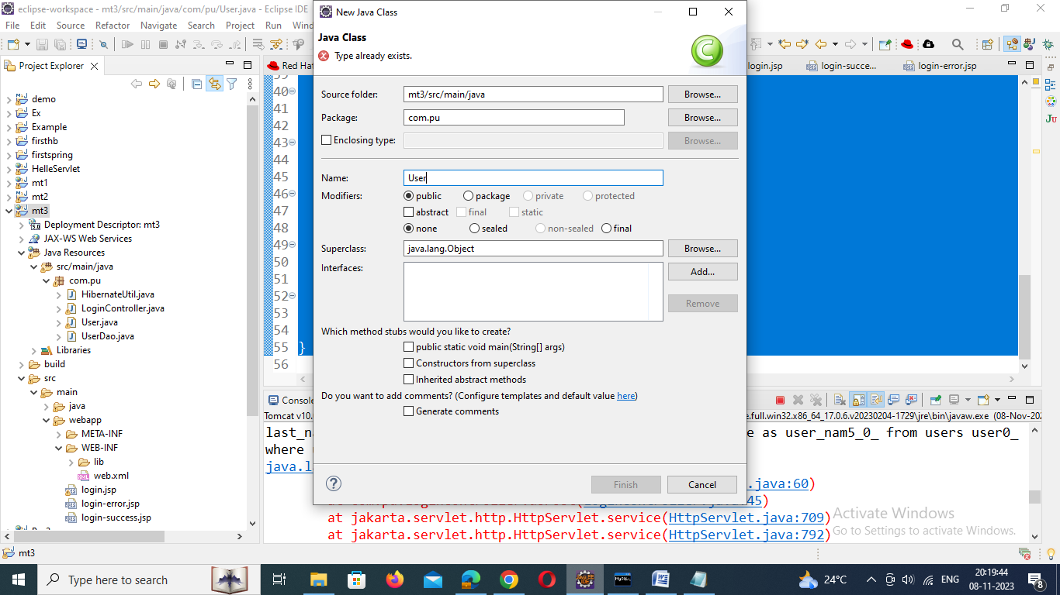

User.java

package com.pu;
import java.io.Serializable;

import javax.persistence.Column;
import javax.persistence.Entity;
import javax.persistence.GeneratedValue;
import javax.persistence.GenerationType;
import javax.persistence.Id;
import javax.persistence.Table;

@Entity
@Table(name = "users")
public class User implements Serializable {

@Id
@GeneratedValue(strategy = GenerationType.AUTO)
private int id;

@Column(name = "first_name")
private String firstName;

@Column(name = "last_name")
private String lastName;

@Column(name = "user_name")
private String username;

@Column(name = "password")
private String password;

public String getFirstName() {
return firstName;
}
public void setFirstName(String firstName) {
this.firstName = firstName;
}
public String getLastName() {
return lastName;
}
public void setLastName(String lastName) {
this.lastName = lastName;
}
public String getUsername() {
return username;
}
public void setUsername(String username) {
this.username = username;
}
public String getPassword() {
return password;
}
public void setPassword(String password) {
this.password = password;
}
}

6. Create UserDao to Save Registered User into Database
Let's create a UserDao class and add the saveUser() method to save Users into the users table in a database using Hibernate.
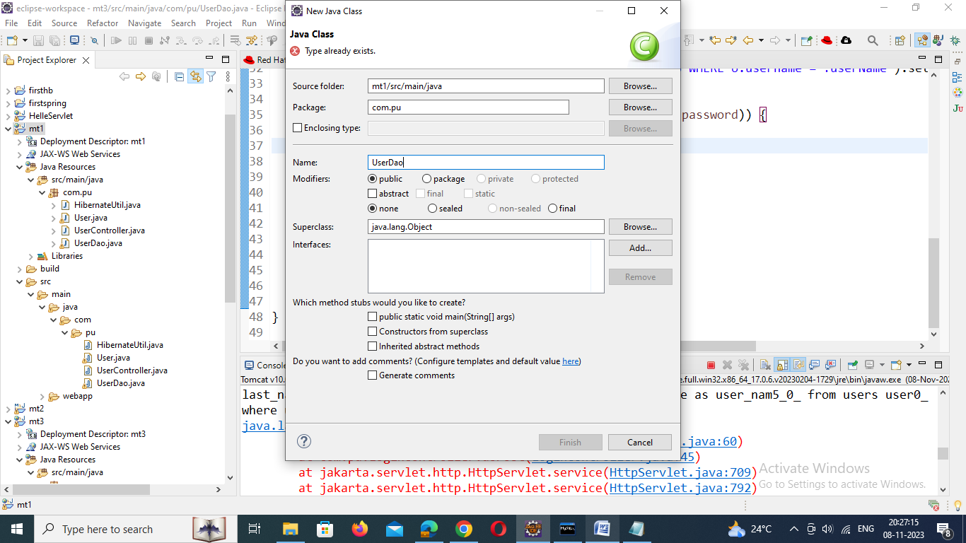
UserDao.java
package com.pu;

import org.hibernate.Session;
import org.hibernate.Transaction;

public class UserDao {
public void saveUser(User user) {
Transaction transaction = null;
try (Session session = HibernateUtil.getSessionFactory().openSession()) {
// start a transaction
transaction = session.beginTransaction();
// save the student object
session.save(user);
// commit transaction
transaction.commit();
} catch (Exception e) {
if (transaction != null) {
transaction.rollback();
}
e.printStackTrace();
}
}

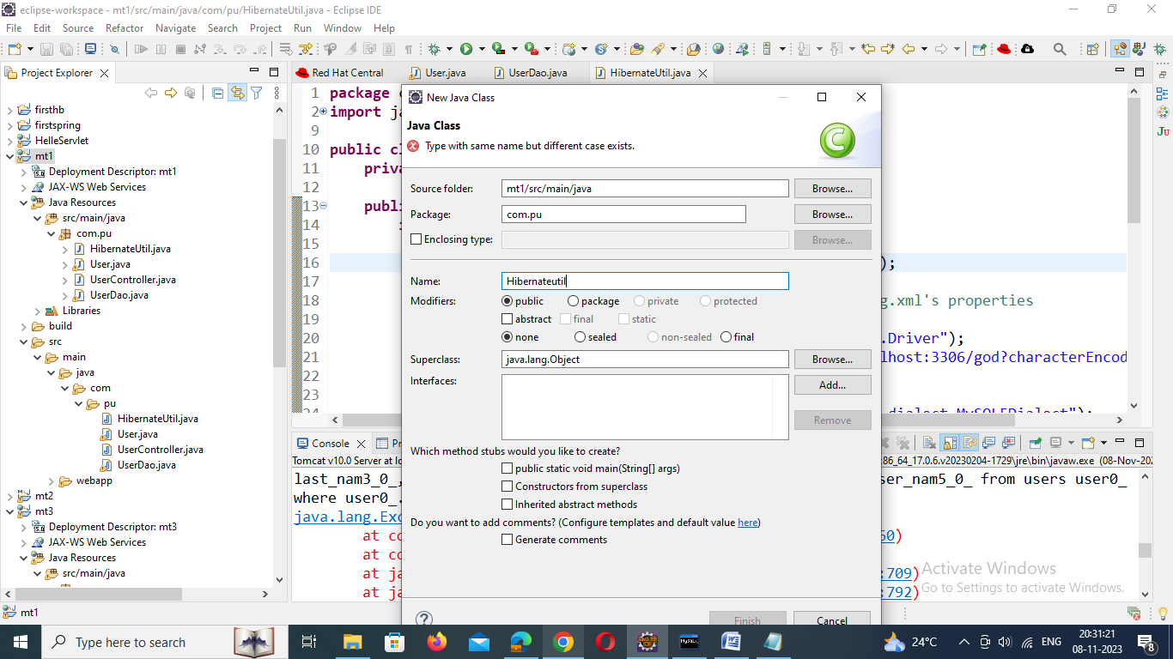

7. Hibernate Java-Based Configuration
HibernateUtil.java
package com.pu;

import java.util.Properties;
import org.hibernate.SessionFactory;
import org.hibernate.boot.registry.StandardServiceRegistryBuilder;
import org.hibernate.cfg.Configuration;
import org.hibernate.cfg.Environment;
import org.hibernate.service.ServiceRegistry;

public class HibernateUtil {
private static SessionFactory sessionFactory;

public static SessionFactory getSessionFactory() {
if (sessionFactory == null) {
try {
Configuration configuration = new Configuration();

// Hibernate settings equivalent to hibernate.cfg.xml's properties
Properties settings = new Properties();
settings.put(Environment.DRIVER, "com.mysql.jdbc.Driver");
settings.put(Environment.URL, "jdbc:mysql://localhost:3306/demo?characterEncoding=latin1");
settings.put(Environment.USER, "root");
settings.put(Environment.PASS, "admin123");
settings.put(Environment.DIALECT, "org.hibernate.dialect.MySQL5Dialect");

settings.put(Environment.SHOW_SQL, "true");

settings.put(Environment.CURRENT_SESSION_CONTEXT_CLASS, "thread");

settings.put(Environment.HBM2DDL_AUTO, "create-drop");

configuration.setProperties(settings);
configuration.addAnnotatedClass(User.class);

ServiceRegistry serviceRegistry = new StandardServiceRegistryBuilder()
.applySettings(configuration.getProperties()).build();
System.out.println("Hibernate Java Config serviceRegistry created");
sessionFactory = configuration.buildSessionFactory(serviceRegistry);
return sessionFactory;

} catch (Exception e) {
e.printStackTrace();
}
}
return sessionFactory;
}
}

8. Create a UserController.java
Now, let's create UserController (servlet) that acts as a page controller to handle all requests from the client:
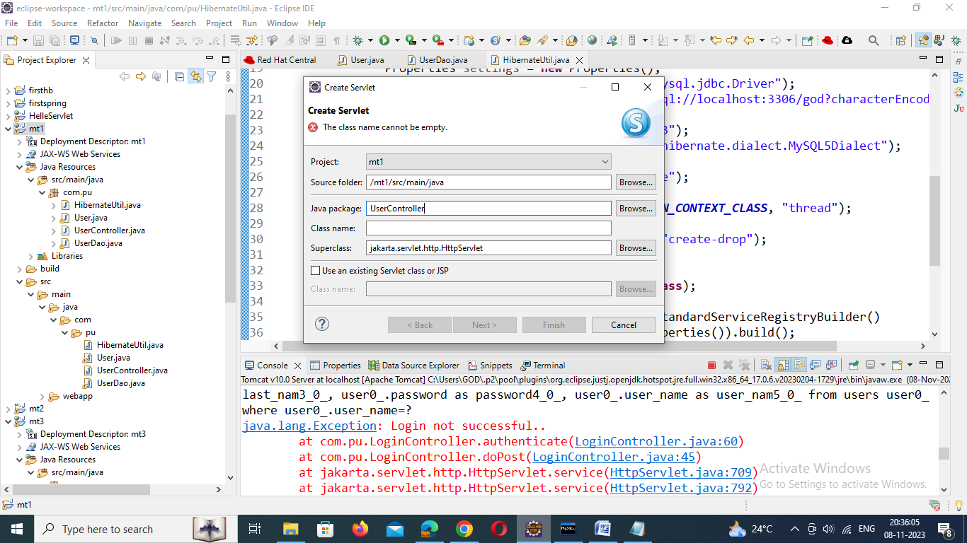

package com.pu;

import jakarta.servlet.ServletException;
import jakarta.servlet.annotation.WebServlet;
import jakarta.servlet.http.HttpServlet;
import jakarta.servlet.http.HttpServletRequest;
import jakarta.servlet.http.HttpServletResponse;
import jakarta.servlet.RequestDispatcher;
import java.io.*;

/**
* Servlet implementation class UserController
*/
@WebServlet("/register")
public class UserController extends HttpServlet {
private static final long serialVersionUID = 1L;
private UserDao userDao;
/**
* @see HttpServlet#HttpServlet()
*/
public UserController() {
super();
// TODO Auto-generated constructor stub
}
public void init() {
userDao = new UserDao();
}
/**
* @see HttpServlet#doGet(HttpServletRequest request, HttpServletResponse response)
*/
protected void doGet(HttpServletRequest request, HttpServletResponse response) throws ServletException, IOException {
// TODO Auto-generated method stub
response.sendRedirect("register.jsp");
}

/**
* @see HttpServlet#doPost(HttpServletRequest request, HttpServletResponse response)
*/
protected void doPost(HttpServletRequest request, HttpServletResponse response) throws ServletException, IOException {
// TODO Auto-generated method stub
register(request, response);
}
private void register(HttpServletRequest request, HttpServletResponse response) throws IOException, ServletException {
String firstName = request.getParameter("firstName");
String lastName = request.getParameter("lastName");
String username = request.getParameter("username");
String password = request.getParameter("password");

User user = new User();
user.setFirstName(firstName);
user.setLastName(lastName);
user.setUsername(username);
user.setPassword(password);

userDao.saveUser(user);

RequestDispatcher dispatcher = request.getRequestDispatcher("register-success.jsp");
dispatcher.forward(request, response);
}

}

9. Create a View - register.jsp
Let's design a user registration HTML form with the following fields:
- firstName
- lastName
- username
- password
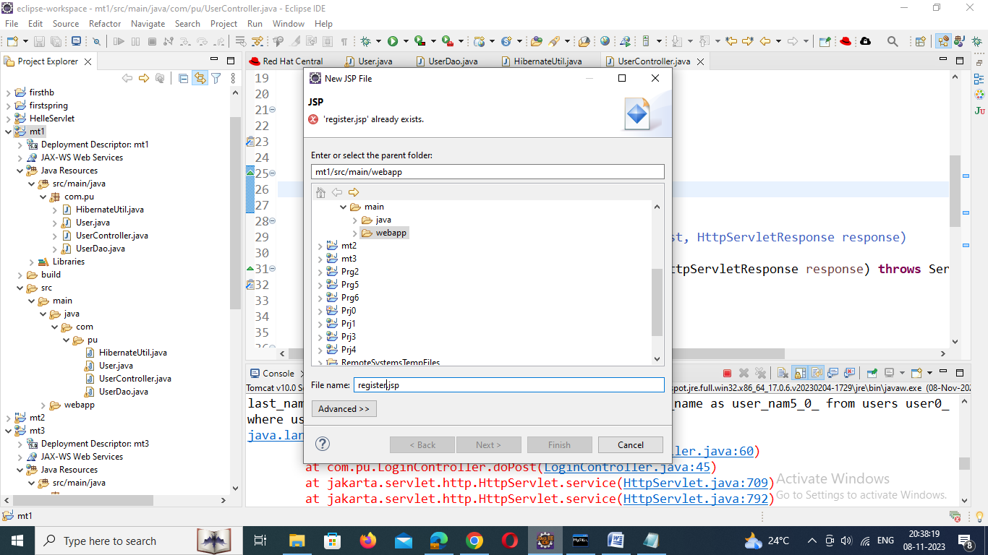
<%@ page language="java" contentType="text/html; charset=ISO-8859-1"
pageEncoding="ISO-8859-1"%>
<!DOCTYPE html>
<html>
<head>
<meta charset="ISO-8859-1">
<title>Insert title here</title>
<link rel="stylesheet"
href="https://stackpath.bootstrapcdn.com/bootstrap/4.3.1/css/bootstrap.min.css"
integrity="sha384-ggOyR0iXCbMQv3Xipma34MD+dH/1fQ784/j6cY/iJTQUOhcWr7x9JvoRxT2MZw1T"
crossorigin="anonymous">

</head>
<body>
<div class="container">
<div class="row text-center" style="color: tomato;">
<h2>User Registration with JSP, Servlet and Hibernate</h2>
</div>
<hr>
<div class="row col-md-10 col-md-offset-3">

<div class="card card-body">

<h2>User Register Form</h2>
<div class="col-md-8 col-md-offset-3">

<form action="<%=request.getContextPath()%>/register" method="post">

<div class="form-group">
<label for="uname">First Name:</label> <input type="text"
class="form-control" id="uname" placeholder="First Name"
name="firstName" required>
</div>

<div class="form-group">
<label for="uname">Last Name:</label> <input type="text"
class="form-control" id="uname" placeholder="last Name"
name="lastName" required>
</div>

<div class="form-group">
<label for="uname">User Name:</label> <input type="text"
class="form-control" id="username" placeholder="User Name"
name="username" required>
</div>

<div class="form-group">
<label for="uname">Password:</label> <input type="password"
class="form-control" id="password" placeholder="Password"
name="password" required>
</div>

<button type="submit" class="btn btn-primary">Submit</button>

</form>
</div>
</div>
</div>
</div>
</body>
</html>

10. Create a View - register-success.jsp
Let's create a register-success.jsp page and add the following code to it:
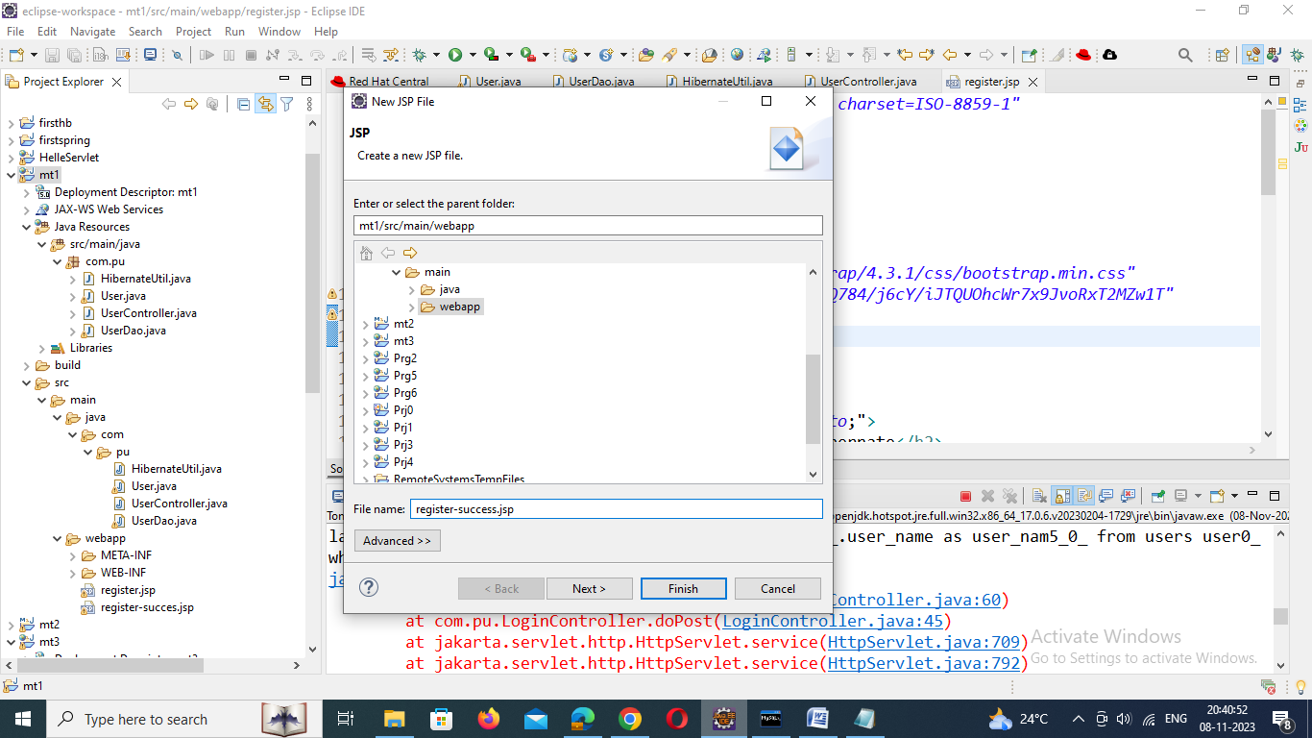
<%@ page language="java" contentType="text/html; charset=ISO-8859-1"
pageEncoding="ISO-8859-1"%>
<!DOCTYPE html>
<html>
<head>
<meta charset="ISO-8859-1">
<title>Insert title here</title>
<link rel="stylesheet"
href="https://stackpath.bootstrapcdn.com/bootstrap/4.3.1/css/bootstrap.min.css"
integrity="sha384-ggOyR0iXCbMQv3Xipma34MD+dH/1fQ784/j6cY/iJTQUOhcWr7x9JvoRxT2MZw1T"
crossorigin="anonymous">
</head>
<body>
<div class="container">
<div class="row col-md-10 col-md-offset-3">
<div class="card card-body">
<h1>User successfully registered!</h1>
</div>
</div>
</div>
</body>
</html>

